Lab 14-1 Creating Users and Groups
Goals | To set up user access so that the Analytics Server can authenticate users and assign them appropriate permissions.
Scenario | You have been instructed to create new users and groups using the Siebel Analytics Administration Tool. Once you have created these users, you will assign them to their appropriate group.
Outcome | Newly created users and security groups. Assigned users as group members.
Time | 10 – 15 minutes
Environment | 
Instructions:
- Open the ABC repository in Online mode.
  - Select Start > Programs > Siebel Analytics > Siebel Analytics Administration.
  - Select File > Open > Online.
  - Click Open to accept the default User and Password.
- Create the user Sara Wright.
  - Check out all objects in the ABC repository by selecting File > Check Out All.
  - Open the Security Manager by selecting Manage > Security.
  - Select Users in the left pane.
  - Right-click in the right pane and select New User.
  - Create the user with the following information:
User name | SWRIGHT
Full Name | Sara Wright
Password | <Blank>
Logging level | 2
Note: Setting the logging level field to 2 ensures query activity will be recorded in the Query Log.
  - Click OK to close the User window.
- Repeat this process and create the following users:
User Name | Full Name | Logging Level
PSMITH | Paul Smith | 0
RMIND | Rob Mind | 0
JCRAFT | Jen Craft | 0
MWEST | Mary West | 2
JMEYER | Jacob Meyer | 2
- In the Security Manager window, verify that your results resemble the following:
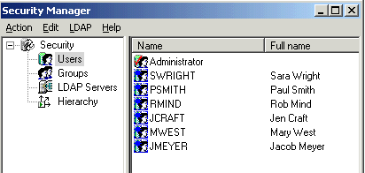
- Create the SalesManagers group and add Sara Wright and Paul Smith to this group.
  - In the left pane of the Security Manager, select Groups.
  - Right-click in the right pane and select New Security Group.
  - Enter SalesManagers in the Name field and click the Add button.
  - Select SWRIGHT.
  - Press CTRL+PSMITH. This allows you to simultaneously select Wright and Smith.
  - Click OK. Wright and Smith are now part of the SalesManagers group.
  - Click OK to close the Group dialog box.
- Repeat this process and create the following two groups and assign users to the groups:
Group Name | Add User
SalesUsers | RMIND, JCRAFT
SalesHR | JMEYER
- Assign MWEST to the Administrators group.
  - Double-click Administrators.
  - Add MWEST.
Note: At this point, the group and user structure resembles the following:
SalesManagers Group |  | SalesUsers Group |  | SalesHR Group |  | Administrators Group
SWRIGHT |  | RMIND |  | JMEYER |  | Administrator
PSMITH |  | JCRAFT |  |  |  | MWEST

- Select Action > Close to close Security Manager.
- Jacob Meyer should not be given access to any of the SupplierSales data. Using the Administration Tool, explicitly prohibit Meyer’s access to this data.
  - In the Presentation layer, double-click SupplierSales.
  - Select the General tab.
  - Click the Permissions button.
  - Double-click the JMEYER check box. The X indicates that Meyer does not have access to the SupplierSales data.
  - Do the remaining users have read access?
  - Why or why not?
  - Click OK to close the Permissions window.
  - Click OK to close the Presentation Catalog window.
- Check in the changes you made into the ABC repository.
  - Select File > Check In Changes, or click the Check In Changes icon 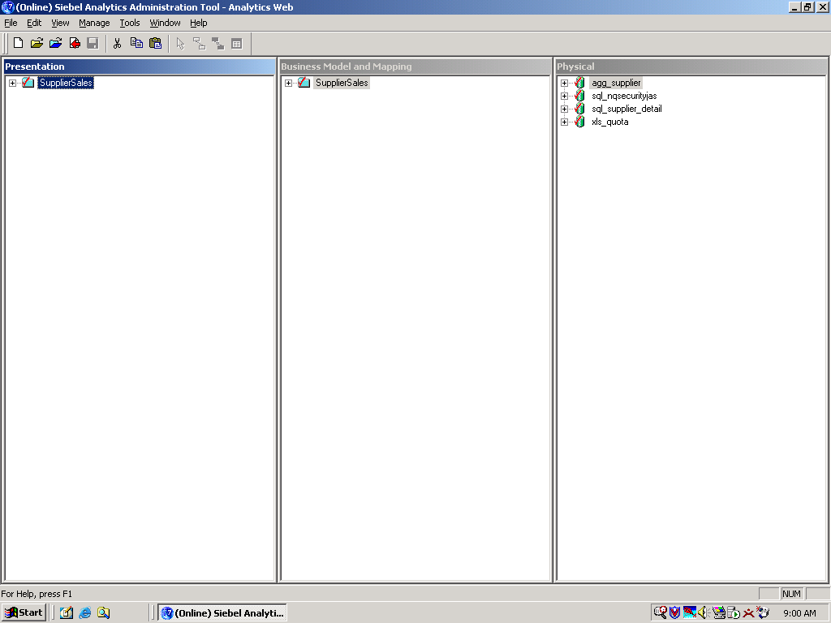.
  - Click No to check consistency.
- Save the changes to the ABC repository by selecting File > Save or clicking the Save icon 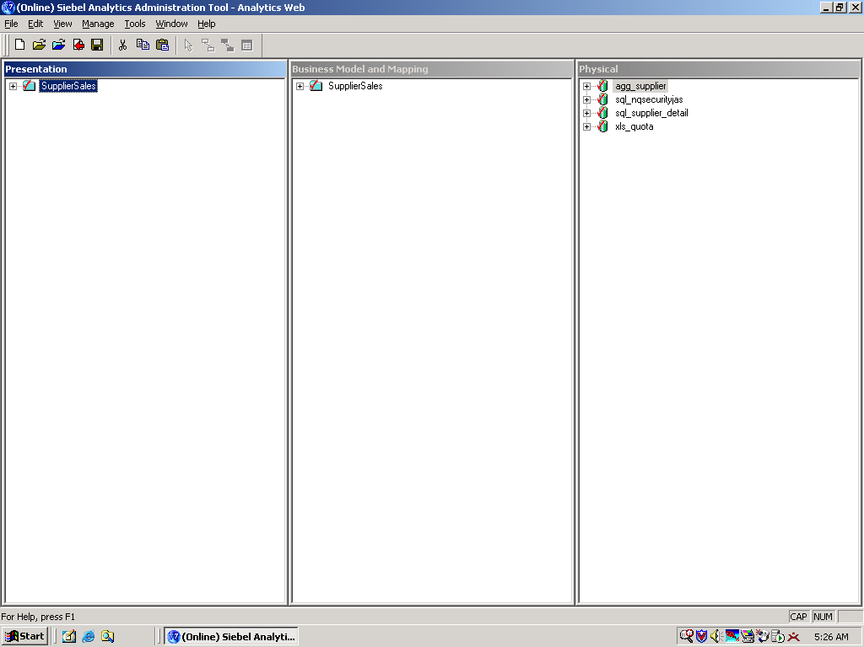.
- With your changes now saved, verify that you can start Siebel Answers as MWEST.
  - Start Siebel Analytics Web and log in with the following parameters:
User ID | MWEST
Password
  - To the left of the Dashboards link, make sure you can see 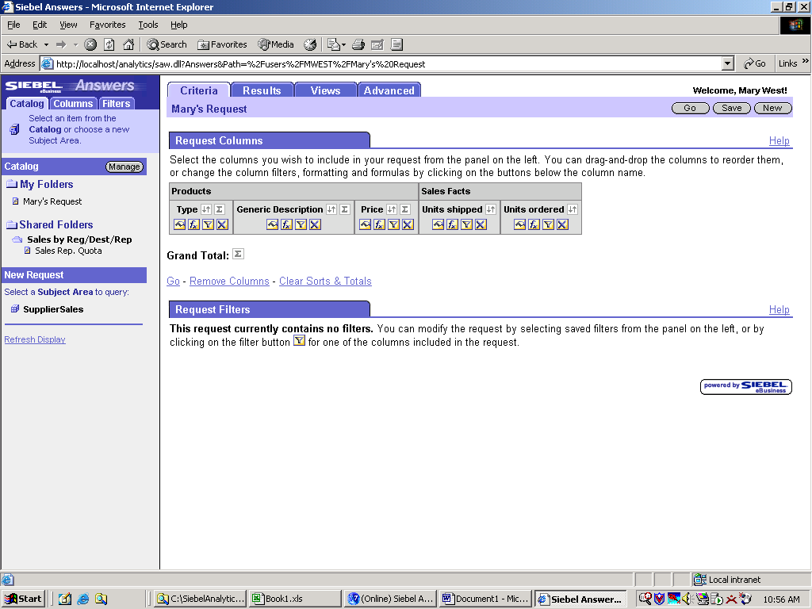to verify that you are logged in as Mary.
  - Click the Answers link.
  - What subject areas are available to Mary?
  - Click the SupplierSales link and notice the objects.
  - Click Log Out in the upper-right corner.
- Start the Siebel Answers application again, this time as JMEYER, and determine if Meyer has the same visibility that West has.
  - To log back in, click the here link.
  - Log in as JMEYER, leaving the password blank.
  - Does the SupplierSales subject area display?
  - Why is this?
  - Select File > Close to exit Siebel Answers.
  - Leave the Administration Tool open for the next lab.

Solutions 14-1 Creating Users and Groups
Answers
9.e. Do the remaining users have read access?
Yes
9.f. Why or why not?
The check box for Everyone is selected. By default, all users and groups are members of the Everyone group. Because the Everyone group has a check mark, all members inherit this permission, unless the member is explicitly denied access.
12.d. What subject areas are available to Mary?
SupplierSales and SupplierSalesDM
13.c. Does the SupplierSales subject area display?
No
13.d. Why is this?
The SupplierSales subject area does not display because you explicitly denied read access to JMEYER.

Lab 14-2 Assigning Permissions to Users
Goals | To set up security access so the Analytics Server can authenticate groups and assign group members appropriate permissions.
Scenario | You will first modify explicit permissions for Jacob Meyer. You will then modify the permission of the group that Jacob Meyer is a member of and examine the affect this has on Meyer. Lastly, you will add Meyer to another group and examine how this affects Meyer’s access.
Outcome | Defined permissions for users and groups.
Time | 10 - 15 minutes
Instructions:
- From the Administration Tool, modify JMEYER’s permissions so that he is no longer explicitly denied access to SupplierSales, but that the group he resides in, SalesHR is.
  - Check out all objects in the repository by selecting File > Check Out All.
  - Double-click the SupplierSales catalog folder and click the Permissions button.
  - Define permissions so that JMEYER is unchecked and SalesHR is explicitly denied.
  - Your results should resemble the following:
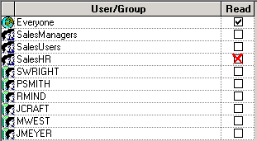
- Now that you have removed JMEYER’s explicit access restrictions from the SupplierSales data, will he be able to execute query requests against it in Siebel Answers? Explain.

- Explicitly assign the SalesManagers group Read permission to the SupplierSales data.
  - Select the SalesManagers group check box.
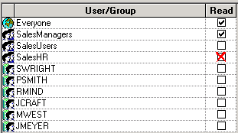
  - Click OK to close the Permissions dialog box.
  - Click OK to close the Presentation Catalog window.
- Add the SalesHR group to the SalesManagers group.
  - Open the Security Manager.
  - Select Groups and double-click SalesManagers.
  - Click the Add button.
  - Select the SalesHR group and click OK. The SalesHR group now belongs to the SalesManagers group.
  - Click OK to close the Group dialog box.

Note: At this point, the group and user structure now resembles the following:

SalesManagers Group
SWRIGHT
PSMITH  SalesHR Group |  | SalesUsers Group |  | Administrators Group
  JMEYER
  RMIND
  JCRAFT
  Administrator
  MWEST

  - Close the Security Manager.
- Check in the changes you made into the ABC repository.
  - Select File > Check In Changes, or click the Check In Changes icon .
  - Click No to check consistency.
Note: When asked to check for consistency, for the purposes of these labs it is not necessary. Always click No.
- Save the changes to the ABC repository.
- With the changes you have made thus far, will JMEYER be able to access the SupplierSales data?

- Verify your answer. Start Siebel Answers as Administrator and register your changes on the Analytics server by updating the Analytics server metadata.
  - Start Siebel Analytics Web and log in as Administrator with no password.
  - Click the Answers link.
  - Click Reload Server Metadata.
Note: Only users with administrator rights have the ability to reload server metadata. This link is not visible to other users.
  - Click Log Out.
  - Log back in as JMEYER with no password.
  - Does this user have access to the SupplierSales subject area now?
  - Why or why not?
  - Select File > Close to exit Siebel Answers.
- Return to the Administration Tool and modify the permissions so that JMEYER also belongs to the SalesManagers group.
(Hint: Remember to check out all objects in the repository.)
  - Open the Security Manager and double-click the SalesManagers group.
  - Click the Add button.
  - Select JMEYER and click OK. Meyer now belongs to both SalesHR and SalesManagers groups.
Note: The group and user structure resembles the following:
SalesManagers Group
SWRIGHT
PSMITH
JMEYER  SalesHR Group |  | SalesUsers Group |  | Administrators Group
  JMEYER
  RMIND
  JCRAFT
  Administrator
  MWEST
- Close the Group window and close the Security Manager.
- Check in the changes and save the repository.
- Log in to Siebel Answers as Administrator and reload the server metadata.
- Verify Meyer’s access to the SupplierSales subject area.
  - Log in as JMEYER to Siebel Answers.
  - Does this user have access to the SupplierSales subject area?
  - Why or why not?
- Select File > Close to exit Siebel Answers.
- Select File > Exit to close the Administration Tool.
Solutions 14-2 Assigning Permissions to Users
Answers
2. Now that you have removed JMEYER’s explicit access restrictions from the SupplierSales data, will he be able to execute query requests against it in Siebel Answers? Explain.
No; JMEYER is a member of the SalesHR group, which was explicitly denied.
7. With the changes you have made thus far, will JMEYER be able to access the SupplierSales data?
No
8.f. Does this user have access to the SupplierSales subject area?
No
8.g. Why or why not?
JMEYER is a member of the SalesHR group, which is explicitly denied. If a user is a direct member of a group, the permissions granted or denied to that group take precedence over permissions granted or denied through other groups.
13.b. Does this user have access to the SupplierSales subject area now?
Yes
13.c. Why or why not?
JMEYER is a member of the SalesHR and SalesManagers groups. Since these groups have conflicting permissions, the user is granted the least restrictive permissions of the two groups.
Lab 14-3 Authenticating Using an External Database
Goals | To authenticate users using an external database.
Scenario | An external database consisting of user login information has been provided for you so that you can import this information into the repository and use it to authenticate users during login. Once this information has successfully been imported, you will need to create an initialization block that will retrieve this data.
Outcome | External database of login information used for authenticating users.
Time | 15 – 20 minutes
Instructions:
- Start Siebel Analytics Web and attempt to log in as Alan Ziff.
  - Enter the following parameters:
User ID | AZIFF
Password | az
  - Click Log In. Click No to remember password.
  - Were you able to log in as this user?
  - Close the Siebel Analytics Log In window.
- Create a new data source that connects to the security database.
  - Select Start > Programs > Administrative Tools > Data Sources ODBC.
  - Select the System DSN tab.
  - Click Add.
  - Scroll down to select SQL Server.
  - Click Finish.
  - Create a new data source with the following parameters:
Name | SECURITY
Server | (local)
  - Click Next.
  - Specify authentication.
    - Select the With SQL Server authentication… radio button.
    - Select the Connect to SQL Server to obtain default settings… check box.
    - Type sa in the Login ID field and leave the Password field blank.
    - Click Next.
  - Specify the default data source.
    - Select the Change the default database to check box.
    - Select Security from the drop-down list.
    - Click Next.
  - Clear all the check boxes.
  - Click Finish.
  - Test that the data source connection is valid:
    - Click the Test Data Source button and verify that you get the message, “…TESTS COMPLETED SUCCESSFULLY!”
    - Click OK.
  - Click OK again.
  - Click OK to close the ODBC Data Source Administrator.
- Shut down the Siebel Analytics Server.
- Double-click C:\SiebelAnalytics\Repository\abc.rpd and log in as Administrator with no password.
- Import tables from the Security database into the repository’s Physical layer.
  - Select File > Import > from Database.
  - Locate and select the SECURITY data source.
  - Click OK.
- Import tables from the security database.
  - Expand the Security folder until both tables appear.
  - Select Security and securitylogons:
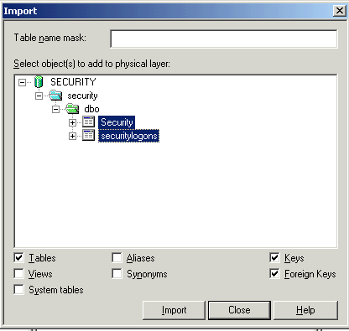
  - Click Import.
  - Click Close.
- Inspect the data that was imported into the Physical layer.
  - In the Physical layer, expand the SECURITY source until both tables appear.
  - Right-click securitylogons.
  - Select View Data. A table appears. List the column header for each column that appears in the table.
  - Who is the first Sales Rep. listed, and what is his or her username and password?
  - Click Close.
- Create an initialization block.
  - Select Manage > Variables.
  - In the left pane, select Initialization Blocks.
  - In the right pane, right-click and select New Initialization Block.
  - In the Name field, type Security.
  - Under the Name field, select associate with session variables from the drop-down list.
  - Create a string that requests username, group, password, and log level variables from the database. The values returned by the database will be assigned to the variables you define. These variables will be used in authenticating a user during login.
    - In the Initialization screen window enter the following script:
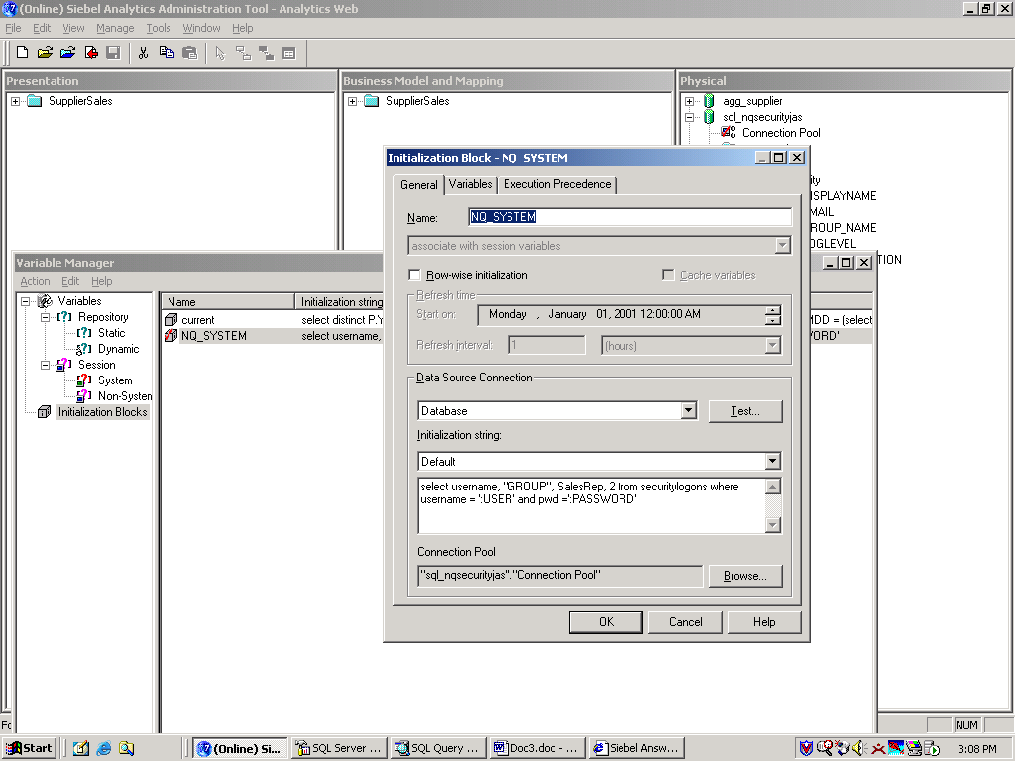
  - Click Browse to assign the connection pool.
    - Expand Security and click Connection Pool.
    - Click Select.
  - Your results should resemble the following:
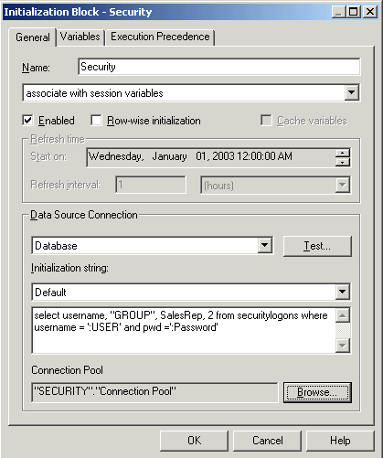
- Because you requested four variables in the string, you will need to define each variable. These variables are USER, GROUP, DISPLAYNAME, and LOGLEVEL.
  - From the Initialization Block window, click the Variables tab.
  - Click New.
  - Enter USER in the Name field.
  - Click OK.
  - Click Yes to acknowledge that this variable has a special purpose.
  - Repeat the process for the remaining three variables.
  - When complete, your table of variables should resemble the following:
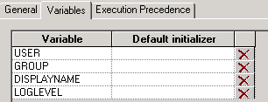
Note: It is important that the order in which your variables are listed be the same as they are listed above.
- Before validating the authentication of these new users in a Web application, conduct a test to see what data is returned for the user Alan Ziff.
  - Click the General tab.
  - Click Test.
  - In the Value field of the USER row, enter AZIFF.
  - In the Value field of the PASSWORD row, enter az.
Note: Notice that these values are populated in the initialization script. If this query returns data, the user is authenticated and session variables will be populated.
  - Click OK and view the results:
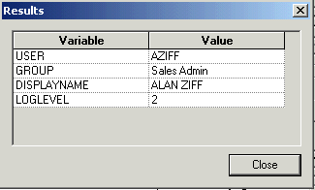
Note: The sequence in which this data is listed is in the same order you defined the variables earlier.
  - Click Close.
  - Click OK to close the Initialization Block window.
  - Close the Variable Manager window.
- Save the changes in the repository and click No to check global consistency.
- Select File > Exit to close the Administration Tool.
- Start the Siebel Analytics Server service.
- Start Siebel Analytics Web and log in as Alan Ziff.
  - Enter the following parameters:
User ID | AZIFF
Password | az
  - Click Log In.
  - Is there a personal greeting for ALAN ZIFF to the left of the Dashboards link?
  - Select File > Close to exit the Siebel Analytics Web.
Solutions 14-3 Authenticate Using an External Database
Answers
1.c. Were you able to log in as this user?
No
7.c. Select View Data. A table appears. List the column header for each column that appears in the table.
Catalog_name, Group, Pwd, Sales Rep, Schema_name, Username
7.d. Who is the first Sales Rep. listed and what is their username and password?
ALAN ZIFF is the rep., AZIFF is the username, and az is the password.
14.c. Is there a personal greeting for ALAN ZIFF to the left of the Dashboards link?
Yes
Lab 14-4 Setting Query Limits and Timing Restrictions
Goals | To disallow queries that may consume too much of the system resources by setting query limits.
Scenario | You want to prevent queries from consuming too many resources by limiting how long a query can run and how many rows a query can retrieve. You also want to disallow users from querying a database during batch processes at specific times on a specific day.
Outcome | Set the maximum rows of any query to five rows, the maximum time of any query to 1 minute, and restrict access to a database on Sunday from 12:00 A.M. to 7:00 A.M.
Time | 10 – 15 minutes
Instructions:
- Open ABC.rpd in Online mode.
  - Select Start > Programs > Siebel Analytics > Siebel Analytics Administration.
  - Select File > Open > Online.
  - Click Open.
- Disallow queries that may consume too many system resources by setting query limits for the SalesManagers group.
  - Check out all objects in the repository.
  - Open the Security Manager.
  - Double-click the SalesManagers group.
  - Click the Permissions button.
  - Select the Query Limits tab.
  - Specify a maximum number of rows each query can retrieve from the ABC database:
    - Locate the ABC database and change its Max Rows value to 5.
    - In the Status Max Rows column, select Enable from the drop-down list.
  - Specify the maximum time a query can run on the ABC database:
    - In the Max Time (Minutes) column, change the value to 1.
    - In the Status Max Time column, select Enable from the drop-down list.
- Restrict the time period that users can access specified repository resources from midnight Sunday to 7:00 A.M. Sunday:
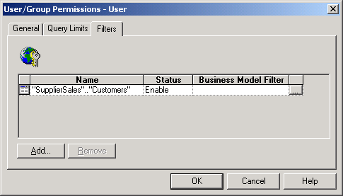
  - Click the Ellipsis button in the Restrict column of the ABC database.
  - Highlight the blocks from Sunday at midnight to 7 AM Sunday.
(Hint: With the first block selected press the SHIFT key and select the 7 AM block.)
  - Click Disallow.
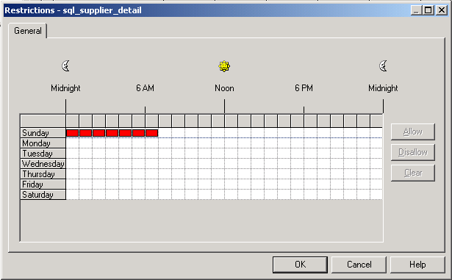
Note: If a time period is not highlighted, access rights remain unchanged. If access is allowed or disallowed explicitly to one or more groups, the user is granted the least restrictive access for the time periods that are defined.
  - Click OK to close the Restrictions dialog box.
  - Click OK to close the User/Group Permissions dialog box.
  - Click OK to close the Group dialog box.
  - Close Security Manager.
- Check in the changes and save the repository. You have successfully restricted access to the ABC database for the SalesManagers group.
- Start Siebel Answers as Administrator and register your changes on the Analytics Server by updating the Analytics Server metadata.
  - Start Siebel Analytics Web and log in as Administrator with no password.
  - Click the Answers link.
  - Click Reload Server Metadata.
  - Click Log Out.
- Verify that the changes you made to the maximum number of rows allowed per query works correctly.
  - Start Siebel Analytics Web and log in as JMEYER with no password.
  - If necessary, click the Answers link.
  - Click the SupplierSales subject area.
  - Select Customers.Customer and click Results.
  - Did the results of the query display?
  - Expand Error Details to view message. What does the error message state?
  - Select File > Close to exit Siebel Answers.
- Return to the Administration Tool and inactivate the query restriction you just created.
  - Check out all objects in the repository.
  - Open the Security Manager.
  - Double-click the SalesManagers group.
  - Click the Permissions button.
  - Select the Query Limits tab.
  - From the ABC row, select Ignore for both Status Max Rows and Status Max Time columns.
  - Click OK.
  - Close all dialog boxes and Security Manager.
- Check in changes and save the repository.
- Close the Siebel Analytics Administration tool.
- Restart the Siebel Analytics Server and Siebel Analytics Web services.
- When the services have completely restarted, test your results.
  - Start Siebel Analytics Web and log in as JMEYER with no password.
  - Click the Answers link.
  - Click the SupplierSales subject area.
  - Select Customers.Customer and click Results.
  - What are the results now?
- Select File > Close to exit Siebel Answers.
Solutions 14-4 Setting Query Limits and Timing Restrictions
Answers
6.e. Did the results of the query display?
No
6.f. What does the error message state?
A general error has occurred. The user request exceeded the maximum query governing rows from the database.
11.e. What are the results now?
The customer rows are returned in the query, since there is no longer a restriction on the number of rows that can be returned from the ABC database.

